- POWER SUPPLY SYSTEM THEORY
1.List 3 real-world devices in your home or college that use SMPS (Switched Mode Power Supply) and 2 devices that use UPS (Uninterruptible Power Supply), explaining in one line why each device needs that type of power supply.
Device | Type | Why it needs this type of power supply
Desktop Computer | SMPS | Converts AC power to multiple stable DC voltages efficiently for internal components like the CPU, RAM, and motherboard.
Laptop Charger | SMPS | Provides efficient voltage conversion from AC mains power to the DC voltage required by the laptop.
LED Television | SMPS | Supplies regulated DC power to the TV's electronic circuits while reducing energy loss.
Desktop Computer with Battery Backup | UPS | Keeps the computer running during power outages, preventing data loss and allowing safe shutdown.
Wi-Fi Router Connected to a UPS | UPS | Maintains internet connectivity during power cuts by providing temporary backup power.

2. Draw and label a diagram showing the main internal components of a typical SMPS unit found in a desktop PC, including AC input, rectifier, transformer, and DC output sections.
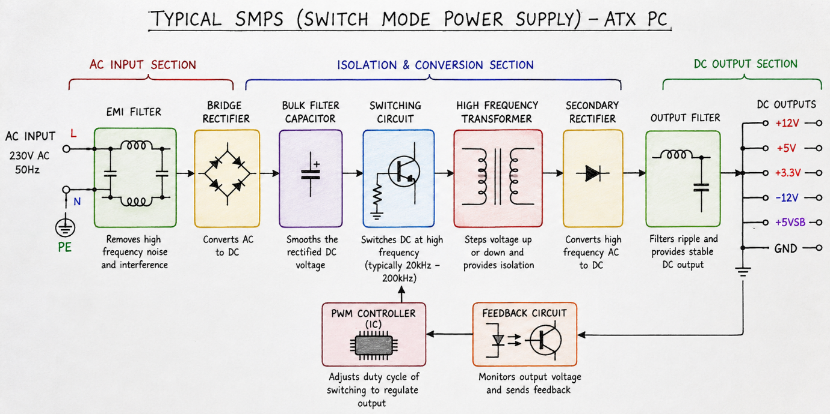
3.Take photos or find clear images online of the following power connectors: ATX 24-pin motherboard connector, SATA power connector, Molex connector, and PCIe 6/8-pin connector. For each, write its name, the devices it powers, and one safety tip for connecting/disconnecting it.
1. ATX 24-Pin Motherboard Connector
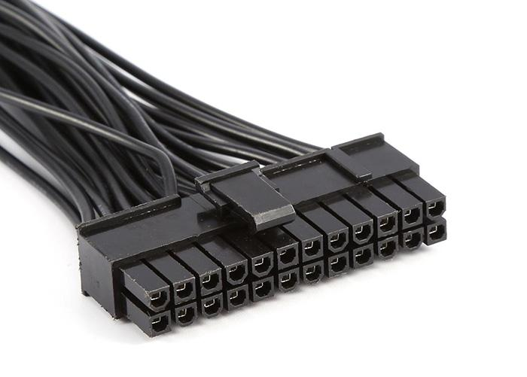
Name: ATX 24-Pin Motherboard Connector
Devices it powers:
- Motherboard (main power connection)
- Supplies power to CPU, RAM, chipset, and expansion slots through the motherboard.
Safety Tip:
- Turn off the PSU and unplug the power cable before connecting or disconnecting the connector. Press the locking clip before removing it to avoid damaging the motherboard.
2. SATA Power Connector
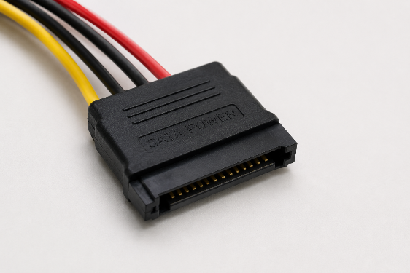
Name: SATA Power Connector
Devices it powers:
- SATA SSDs
- SATA HDDs
- Optical drives (DVD/Blu-ray drives)
- Some RGB controllers and accessories.
Safety Tip:
- Align the L-shaped connector correctly and never force it into the drive. A forced connection can break the connector.
3. Molex Connector (4-Pin Peripheral Connector)
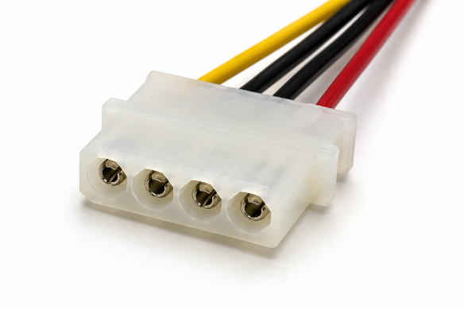
Name: Molex 4-Pin Connector
Devices it powers:
- Older hard drives
- Optical drives
- Case fans
- Other legacy peripherals.
Safety Tip:
- Pull the connector by its plastic body, not by the wires, when disconnecting it.
4. PCIe 6/8-Pin Connector
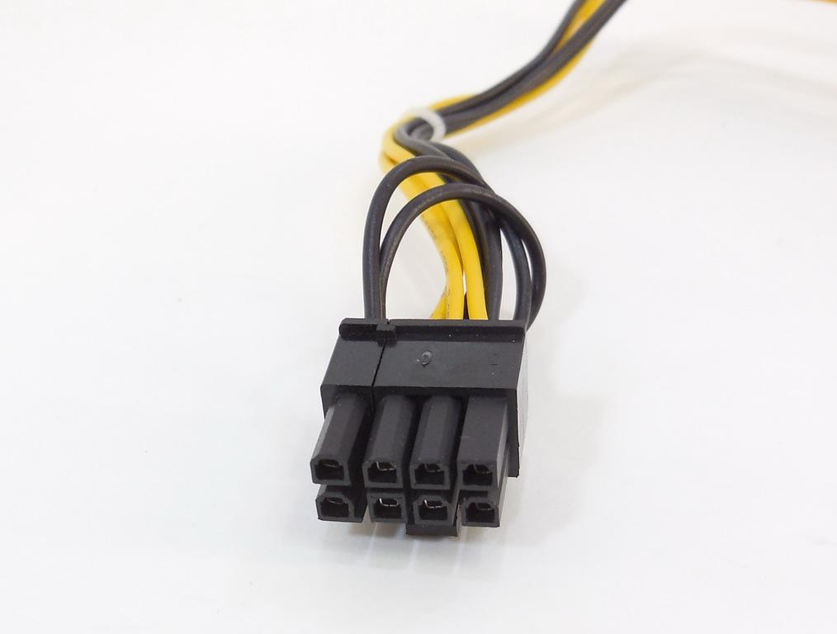
Name: PCIe 6-Pin / 8-Pin Power Connector
Devices it powers:
- Graphics cards (GPUs)
- High-performance PCIe expansion cards.
Safety Tip:
- Ensure the locking clip clicks into place and use only the correct PCIe power cable from the PSU. Do not force incompatible connectors.
4. Imagine you are setting up a new gaming PC. List the steps you would follow to connect the SMPS to the motherboard, graphics card, and storage devices, mentioning which specific cables and connectors are used for each.
Steps to Connect the SMPS in a Gaming PC
- Install the SMPS in the cabinet and secure it with screws.
- Connect the 24-pin ATX power cable from the SMPS to the motherboard.
- Connect the 8-pin (4+4) CPU power cable to the CPU power socket on the motherboard.
- Connect the PCIe 6-pin/8-pin (6+2) power cable to the graphics card (GPU).
- Connect SATA power cables to the SSD, HDD, and optical drives.
- Connect Molex connectors to any older fans or legacy devices if required.
- Check that all connectors are firmly attached and manage cables neatly.
- Connect the AC power cord, switch on the SMPS, and start the PC.
Component | Connector Used
Motherboard | 24-pin ATX
CPU | 8-pin (4+4) CPU/EPS
Graphics Card | PCIe 6-pin/8-pin
SSD/HDD | SATA Power
Legacy Devices | 4-pin Molex
Safety Tip: Always turn off and unplug the power supply before connecting or disconnecting any cables.

